“Tusk Fragment with the Ascension”

Byzantine Art and Architecture Visual Analysis Assignment

Jacob Stewart

REL 745 - Byzantine Art and Architecture

Prof. Vasileios Marinis

Within the realm of Byzantine art, this Tusk Fragment with the Ascension is an intriguing piece, inviting deep exploration into its composition, significance, and potential purpose as a representative work of Byzantine culture. In this paper, I will attempt to provide an in-depth visual description of, an exploration of the visual language utilized within, and ultimately suggest some likely uses for the object. I will conclude by offering some speculations of my own, extrapolating from other art in the period.
At the outset, it is important to note that this is ivory. It’s curved along the vertical axis, leaning slightly to the right, and exhibits a semi-circular contour along the horizontal axis, utilizing the inherent shape of an elephant’s tusk. The composition is made leveraging the natural structure of the material, but the maker has bisected the tusk, this piece presenting its subject in a semi-circular fashion. Approximately 8 inches tall and 5 inches wide, it utilizes the larger portion of the elephant's tusk near its base. Its nature as ivory is also evident from the damage and visible bone-like flaking, notably in the bottom right-hand corner. Examining the back of the image reveals the internal structure of this ivory section. Also, it is important to note that as an ivory, it almost certainly appeared in a more brilliant white color at the time of its creation and has over time acquired its more brownish color.
It likely would be labeled a Bas-relief , distinct from a sculpture in the round due to its shallower depth. However, the curved nature of the material lends it a unique perspective, particularly noticeable from either side. This curvature allows the viewer to observe sections of the piece at a time, an effect unattainable in flat relief carvings. This carving style, with its flatter nature, exists in a realm between two-dimensionality—often found on flat surfaces—and in-the-round sculptures. Strategically placed holes—one at the top center and two on either side—suggest that this constitutes the very top of this piece, as these holes likely facilitated its display, either through hanging freely or by fastening it to a wall.
The carving presents twelve figures divided into two registers—five in the top register and seven in the lower register. Its style is abstract, and exhibits many geometric characteristics, accentuated by various decorative elements. Notably, a “decorative punch,” basically an encircled dot, is a prominent feature, appearing abundantly across the object, with a concentration in the top register, totaling over 130 occurrences. The artist has used the decorative punch to also create the twelve figures’ pupils, giving them the appearance of peering directly out. In the subsequent paragraphs, I will provide a more detailed description of the figures within these registers and then I will explore comparative aspects, examining how these two registers engage in a dialogue with one another.
In the top register, the composition features four figures surrounding a central seated figure placed upon a throne. This central figure is adorned with a cruciform halo encircling the head and further enclosed within a full-body halo or mandorla. The four surrounding figures, each having a set of wings, hold the mandorla aloft with both hands. Depicted horizontally, these figures are portrayed in flight, their bodies positioned perpendicular when compared to all the other figures. The central seated figure is shown holding a book open in one hand while gesturing a sign of blessing with the other. The central figure is that of Christ, and the four surrounding figures are angels, attending to Christ’s mandorla.
The bottom register features six figures surrounding a central figure, all standing. The central figure is depicted gesturing with hands in an orans position, a posture associated with prayer. The six surrounding figures exhibit almost identical features—sporting pointed beards, identical faces, and wearing similar attire. In contrast, the central figure stands out, devoid of facial hair and adorned in distinctive clothing. The central figure also has several other unique qualities; they are the only figure without a belt and are wearing a veil covering their hair, indicating that this is a woman. The central figure is a depiction of Mary, and the surrounding men are some of the Apostles.
Several comparisons could also be drawn between Mary and the angels within the composition. Despite the angels wearing belts—a detail seemingly associated with maleness—like Mary, they are depicted without beards, possibly signifying a youthful appearance. However, a more nuanced similarity lies in the technique employed to craft Mary's veil, mirroring the method used for the angels' hair. These subtle comparisons raise intriguing questions about whether these visual parallels hint at the almost angelic nature attributed to the mother of Christ.
Considering the composition, however, two axes of symmetry are evident. Each register portrays a central figure attended by identical figures at their sides, mirroring each other along the vertical dimension. The top register, featuring an angelic host, symbolizes a heavenly reality, while the bottom register depicts an earthly one. Hieratic perspective is employed in both registers, apparent not only in the central positioning of Mary and Jesus but also in their relative sizes: Mary, is slightly larger than the apostles at her side, while Jesus, seated, is proportionally similar in size to Mary.
The use of clothing in this piece signifies more than just gender distinctions for Mary. She wears a scarf draping over her chest and features a unique raised decorative 'X' or cross on her dress, distinguishing her from the debossed crosses on the books held by Jesus and the apostles. These details differentiate her from the other figures within the composition. All figures, including the Apostles and Mary, don imperial-looking robes or clerical vestments indicative of high-ranking individuals belonging to a distinguished class, such as wealthy elites, bishops, or magistrates.
Notably, each male figure, angels included, sports a thick, corded belt—a departure from the usual style seen in other Byzantine iconography. This choice, perhaps indicative of the prevalent regional style during the creation period, diverges from the norm where belts are worn under the flowing parts of the dress. This deviation raises questions about the influence of contemporary fashion on interpretations of historical events.
Further distinguishing the top register are the figures' attire: tightly fitting sleeved tops reminiscent of military clothing, which we see throughout the Byzantine period. Jesus's attire stands apart, featuring a diamond-checked pattern, each diamond inscribed with a decorative cross, resembling the klivanion or cuirass, a plated military armor worn by officers of the period. If intentional, this choice infuses the entire composition with a distinctly militaristic undertone, however, it is also likely meant to simply represent an elaborate tunic adorned with crosses.
This is a depiction of the Ascension. It shares similarities with other depictions of this type, such as the representation found in the Rabbula Gospels. Like this Tusk Fragment, the Rabbula Gospels depict Jesus surrounded by angels in a mandorla above, while Mary occupies the central position at the bottom, encircled by the apostles. Although differences exist between them, a striking similarity lies in the positioning and gesture of Mary. In both, Mary is centrally placed, facing outward, with hands raised in an orans position.
After examining the visual elements of this object, I find it fitting to delve deeper into its potential use. Notably, ivory items like this were exceptionally costly, typically beyond the reach of anyone but the wealthy elite. Beyond the inherent expense of ivory due to its rarity and the challenges of obtaining it, the carving process itself demanded considerable skill and expense. This suggests that whoever owned or received this item was likely a person of considerable wealth, prominence, or possibly even the emperor himself.
Considering its features, the presence of holes within the object strongly suggests it was intended for hanging or installation in a particular space. The size indicates a potential devotional use, either as a private devotional item for a wealthy individual or high-ranking religious figure, adorning a private space, or as an object of collective devotion in a church setting, positioned for close viewing—possibly at eye level.
However, owing to its considerable cost, it might also have served as part of diplomatic gift-giving or internal rewards within the Byzantine Empire. Imperial administrators and the emperor regularly exchanged gifts, often with reciprocal expectations. For example, if presented to a high-ranking bishop, it might imply ongoing loyalty to the ruler.
The origin of this object in Egypt or Palestine, outside the period of Byzantine control in the period it dates to (720–970 C.E.), suggests its involvement in international exchanges beyond the empire's dominion. Supporting this is the display of another identical ivory fragment alongside this piece, indicating a workshop producing multiple similar objects for regular exchanges rather than a specially commissioned artwork.
Speculatively, the militaristic aspects of Christ's attire might denote its association with themes of militarism, promoting the strength of the gifting empire. Conceivably it could have been bestowed upon high-ranking military officials in exchange for their loyalty and service.
Exploring the apostles' depiction in the lower register, while four hold books inscribed with crosses, indicating gospel writers, the six figures mostly appear identical. Damage obscures the far-right figure, but intriguingly, the two leftmost apostles have chest crosses, suggesting martyrdom. The apostle just right of Mary lacks a chest cross but holds something at the belt's side—maybe a scroll, quill, or dagger. Tradition suggests Saint John the Evangelist was not martyred, so perhaps it is John who appears just right of Mary, without the cross of a martyr. However, the existence of the gospel books demonstrates at least some collapse of historical time. Simply put, the gospel writers couldn’t have penned their gospels by the time of the Ascension, since the Ascension is an account in those books. However, Byzantine art often merges space and time, symbolizing a spiritual, rather than literal or historical, interpretation of this portrayal of the events. Further, the holding of the gospel books could be read more simply as attributes of these four Apostles, giving us a means of simply identifying them.
Additionally, the gestures depicted—four apostles pointing towards their gospel books, Mary pointing to Christ above, and angels also pointing towards Christ—hold potential theological significance. These positions could symbolize varying levels of access or closeness to Christ, where Mary and the angels again possess intriguing similarities.
An even more speculative piece of interpretation has to do with the decorative punch motif. While one might argue that these punches are solely decorative elements, the technique used to create them—also employed for crafting the eyes—and the concentration of more than half of these punches on the mandorla, I find to be noteworthy. I was initially tempted to argue that these punches all symbolize eyes, since we do have examples of many-eyed angelic beings commonly depicted around Jesus during the Ascension, as observed in the Rabbula Gospels. However, in this instance, I find the argument for all punches representing eyes less compelling, given the placement in the clothes of all the figures. Instead, I propose that these punches symbolize twinkling light. I perceive them as the radiance (or starlight) emanating from the mandorla, the glimmer of the eyes, or the shimmering effect seen in fine silk—all capable of emitting light. Considering the initial brilliant white appearance of the carved ivory and its likely illumination by candlelight, especially if the ivory was polished, these punches might have exhibited a sparkle or a different light-catching quality than can be seen today. So, I choose to interpret these punches as a representation of luminescence.
The Tusk Fragment with the Ascension encapsulates the rich tapestry of Byzantine artistry, inviting deep contemplation of its form, symbolism, and cultural context. Crafted from ivory, this bas-relief, with its celestial and earthly registers, narrates a story of divine and mortal realms, symbolized by Christ, Mary, and attendant figures. Its opulent material and craftsmanship suggest ownership by a prominent, wealthy individual, raising questions about its intended use—whether as a devotional object, a diplomatic gift, or a marker of loyalty within the Byzantine Empire. In whatever way this ivory was used this piece goes well beyond a simple portrayal of a biblical account. Rather, it showcases how the art of this period blends spiritual practice, culture, and politics, through a deeply embedded and culturally interpreted visual language that takes time to read.

Fig 1. – (front)  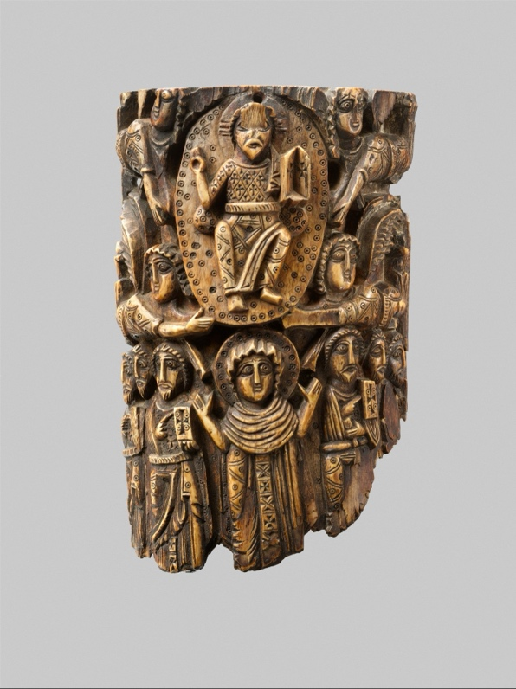 | Fig 2. – (back)  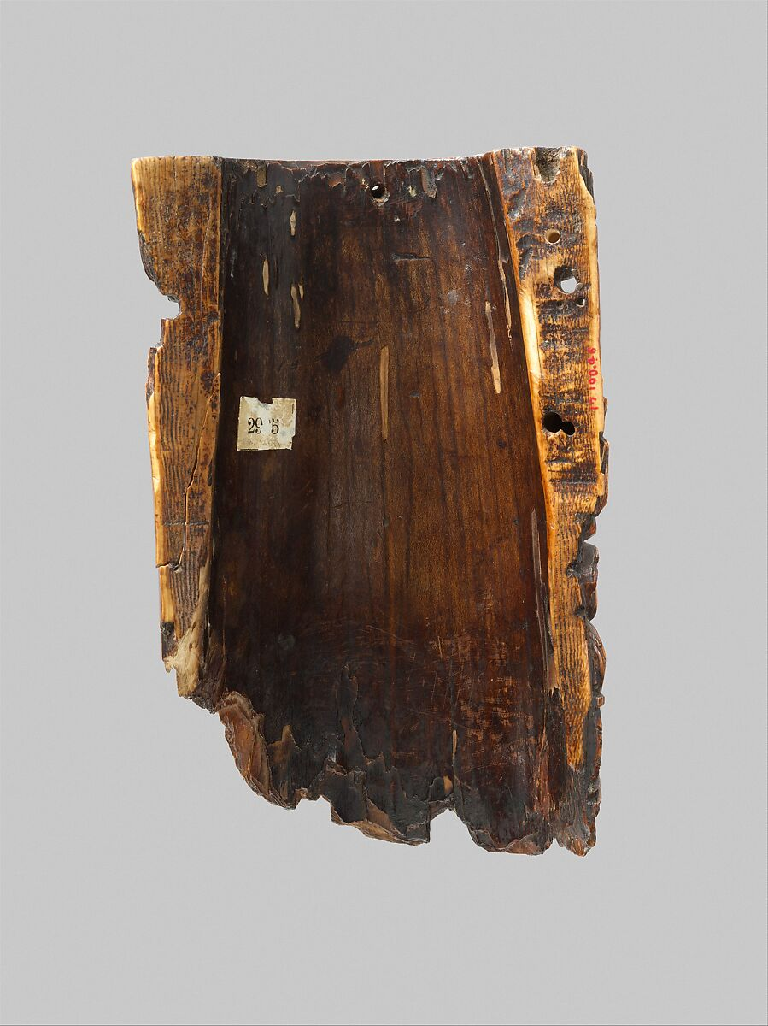
Fig. 3 – (left side)  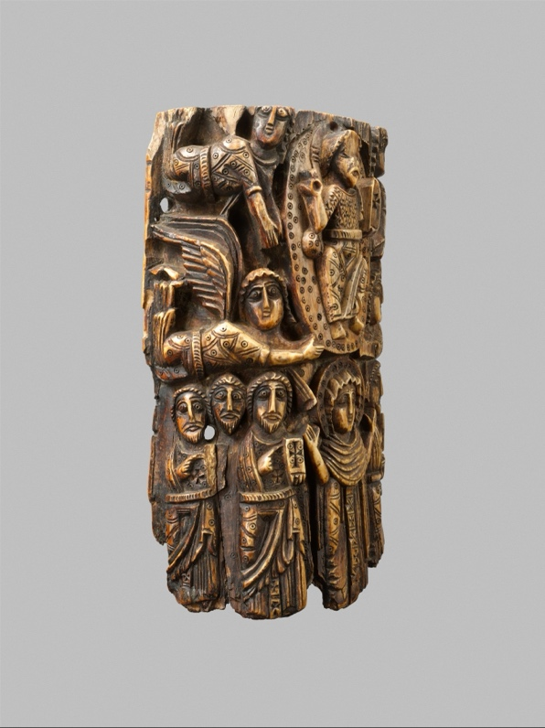 | Fig. 4 – (right side)  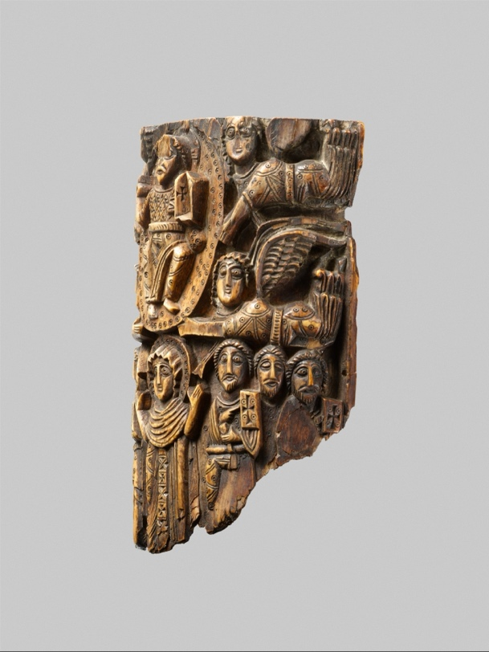

Fig. 5 – (from bottom)  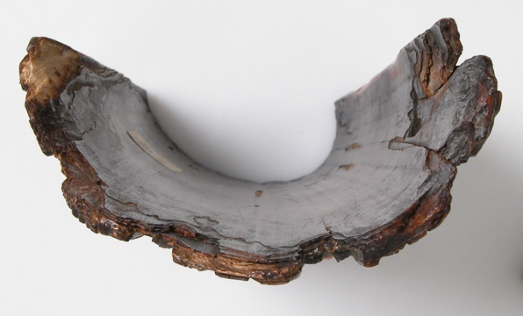 | Fig. 6 (same type – exhibited together)  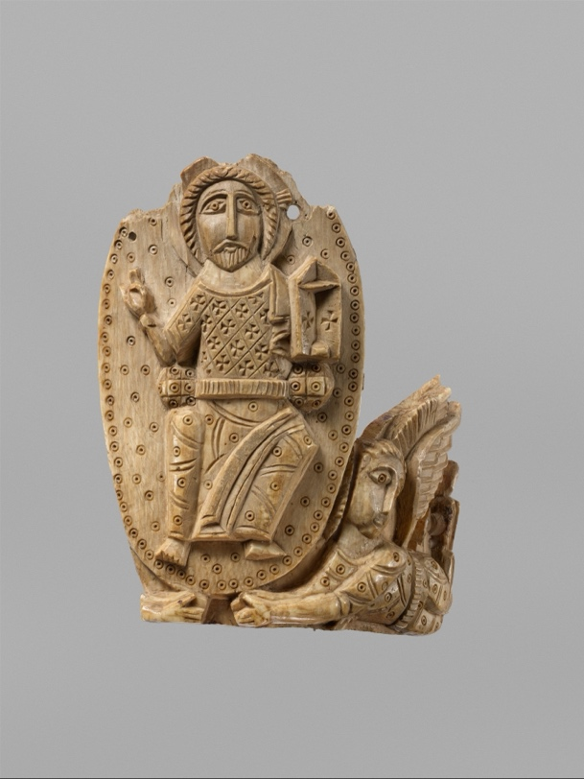

“Tusk Fragment with the Ascension” (720–970 C.E.) Attributed to Egypt or Palestine. The Metropolitan Museum of Art - Accession Number: 17.190.46
See Fig. 1
See Fig. 5
See Fig. 2
Oxford English Dictionary, s.v. “bas-relief, n., sense 1”, September 2023.
See Figs. 3 & 4
Oxford English Dictionary, s.v. “cuirass, n., sense 1”, July 2023.
Rabbula Gospels: Cod. Plut. I. 56: Fol. 13v: Ascension. text written c.586. Biblioteca medicea laurenziana.
See Fig. 6
See Fig. 4

